Lexical Analysis

🧠 What is Lexical Analysis?
# Source: AI Source: Provided by: [Data Path: Persons Table -> ID Column: 1, Name_En Column: Motasem Essam] -> From: [Chatgpt (GPT‑5 Mini)] on [1/26/2026]
Lexical analysis is the first phase of a compiler or interpreter. It takes your raw source code (a string of characters) and breaks it into meaningful pieces, called tokens.

🔹 Key Idea:
# Source: AI Source: Provided by: [Data Path: Persons Table -> ID Column: 1, Name_En Column: Motasem Essam] -> From: [Chatgpt (GPT‑5 Mini)] on [1/26/2026]
Lexical analysis turns characters → tokens.
A token is a basic unit of code, such as:
- Keywords (if, while)
- Identifiers (x, total)
- Operators (+, ==)
- Literals (123, 'hello')
- Symbols ((, ), {, })

📦 What the Lexer (Lexical Analyzer) Does:
# Source: AI Source: Provided by: [Data Path: Persons Table -> ID Column: 1, Name_En Column: Motasem Essam] -> From: [Chatgpt (GPT‑5 Mini)] on [1/26/2026]
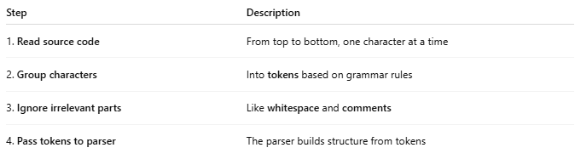
Step | Description
1. Read source code | From top to bottom, one character at a time
2. Group characters | Into tokens based on grammar rules
3. Ignore irrelevant parts | Like whitespace and comments
4. Pass tokens to parser | The parser builds structure from tokens

🧪 Example:

Input Code:
# Source: AI Source: Provided by: [Data Path: Persons Table -> ID Column: 1, Name_En Column: Motasem Essam] -> From: [Chatgpt (GPT‑5 Mini)] on [1/26/2026]
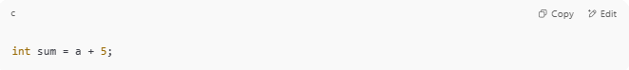
int sum = a + 5;

Lexer Output (Tokens):
# Source: AI Source: Provided by: [Data Path: Persons Table -> ID Column: 1, Name_En Column: Motasem Essam] -> From: [Chatgpt (GPT‑5 Mini)] on [1/26/2026]
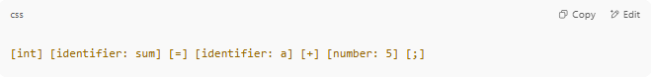
[int] [identifier: sum] [=] [identifier: a] [+] [number: 5] [;]

The parser receives this clean stream of tokens — no noise.

🔧 Real-World Lexer Output Example (Python Style):
# Source: AI Source: Provided by: [Data Path: Persons Table -> ID Column: 1, Name_En Column: Motasem Essam] -> From: [Chatgpt (GPT‑5 Mini)] on [1/26/2026]
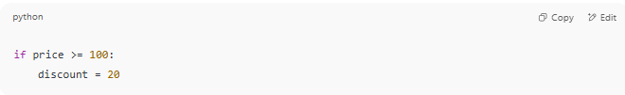
if price >= 100:
discount = 20

Would become:
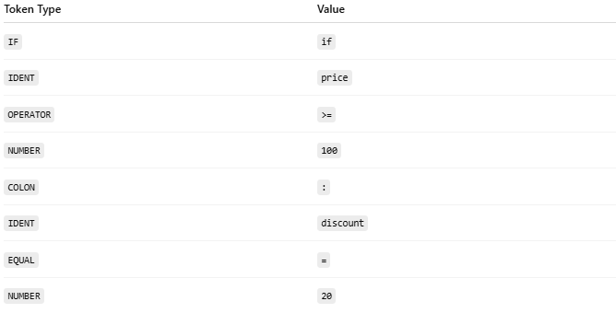
Token Type | Value
IF | if
IDENT | price
OPERATOR | >=
NUMBER | 100
COLON | :
IDENT | discount
EQUAL | =
NUMBER | 20

🧰 Lexer Tools (Lexical Analyzers)
# Source: AI Source: Provided by: [Data Path: Persons Table -> ID Column: 1, Name_En Column: Motasem Essam] -> From: [Chatgpt (GPT‑5 Mini)] on [1/26/2026]
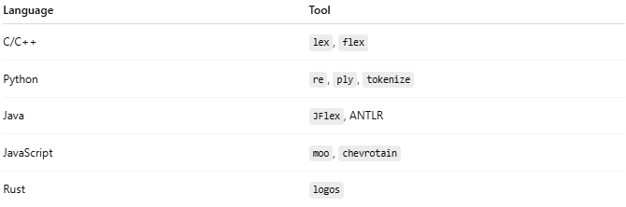
Language | Tool
C/C++ | lex, flex
Python | re, ply, tokenize
Java | JFlex, ANTLR
JavaScript | moo, chevrotain
Rust | logos

🧠 Role of Lexer in a Compiler
# Source: AI Source: Provided by: [Data Path: Persons Table -> ID Column: 1, Name_En Column: Motasem Essam] -> From: [Chatgpt (GPT‑5 Mini)] on [1/26/2026]
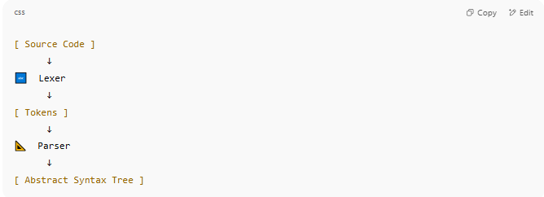
[ Source Code ]
↓
🔤 Lexer
↓
[ Tokens ]
↓
📐 Parser
↓
[ Abstract Syntax Tree ]

✅ Why Lexical Analysis is Important
# Source: AI Source: Provided by: [Data Path: Persons Table -> ID Column: 1, Name_En Column: Motasem Essam] -> From: [Chatgpt (GPT‑5 Mini)] on [1/26/2026]
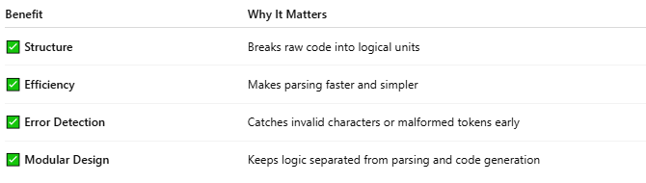
Benefit | Why It Matters
✅ Structure | Breaks raw code into logical units
✅ Efficiency | Makes parsing faster and simpler
✅ Error Detection | Catches invalid characters or malformed tokens early
✅ Modular Design | Keeps logic separated from parsing and code generation

🧭 Lexical Analysis Process Diagram
# Source: AI Source: Provided by: [Data Path: Persons Table -> ID Column: 1, Name_En Column: Motasem Essam] -> From: [Chatgpt (GPT‑5 Mini)] on [1/26/2026]
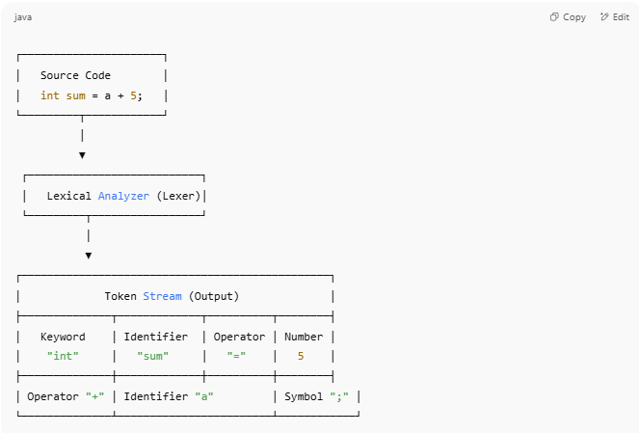
┌──────────────────────┐
│ Source Code │
│ int sum = a + 5; │
└─────────┬────────────┘
│
▼
┌───────────────────────────┐
│ Lexical Analyzer (Lexer)│
└─────────┬─────────────────┘
│
▼
┌────────────────────────────────────────────────┐
│ Token Stream (Output) │
├──────────────┬─────────────┬──────────┬────────┤
│ Keyword │ Identifier │ Operator │ Number │
│ "int" │ "sum" │ "=" │ 5 │
├──────────────┼─────────────┼──────────┼────────┤
│ Operator "+" │ Identifier "a" │ Symbol ";" │
└──────────────┴────────────────────────┴────────────┘

🔍 What Happens at Each Step?

🔹 1. Source Code
# Source: AI Source: Provided by: [Data Path: Persons Table -> ID Column: 1, Name_En Column: Motasem Essam] -> From: [Chatgpt (GPT‑5 Mini)] on [1/26/2026]
Raw program written by the developer (e.g., int sum = a + 5;)

🔹 2. Lexical Analyzer
# Source: AI Source: Provided by: [Data Path: Persons Table -> ID Column: 1, Name_En Column: Motasem Essam] -> From: [Chatgpt (GPT‑5 Mini)] on [1/26/2026]
The lexer:
- Scans input left to right
- Groups characters into tokens
- Ignores whitespace and comments
- Sends tokens to the parser

🔹 3. Token Stream
# Source: AI Source: Provided by: [Data Path: Persons Table -> ID Column: 1, Name_En Column: Motasem Essam] -> From: [Chatgpt (GPT‑5 Mini)] on [1/26/2026]
The output is a clean list of tokens like:
- KEYWORD: int
- IDENTIFIER: sum
- OPERATOR: =
- IDENTIFIER: a
- OPERATOR: +
- NUMBER: 5
- SEMICOLON: ;
Each token has a type and a value.

🧠 Why Use This Diagram?
# Source: AI Source: Provided by: [Data Path: Persons Table -> ID Column: 1, Name_En Column: Motasem Essam] -> From: [Chatgpt (GPT‑5 Mini)] on [1/26/2026]
This view helps you understand:
- Where lexical analysis sits in the compilation pipeline
- What it does to your code
- How it simplifies the job of the parser

🧩 Summary
# Source: AI Source: Provided by: [Data Path: Persons Table -> ID Column: 1, Name_En Column: Motasem Essam] -> From: [Chatgpt (GPT‑5 Mini)] on [1/26/2026]
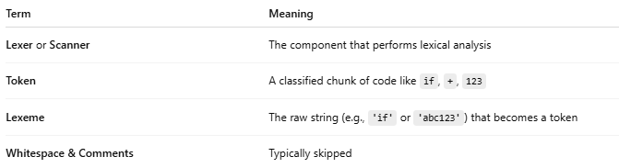

Term | Meaning
Lexer or Scanner | The component that performs lexical analysis
Token | A classified chunk of code like if, +, 123
Lexeme | The raw string (e.g., 'if' or 'abc123') that becomes a token
Whitespace & Comments | Typically skipped

